Chapter 10, Problem 69.

For the differentiator shown in Fig. 10.112, obtain V_{o}/V_{s}. Find v_{o}(t) when
v_{s}(t) = V_{m} sinω t and ω = 1/RC.

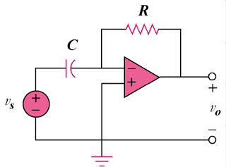

Figure 10.112
For Prob. 10.69.

